Henrietta Lacks 1920 - 1951
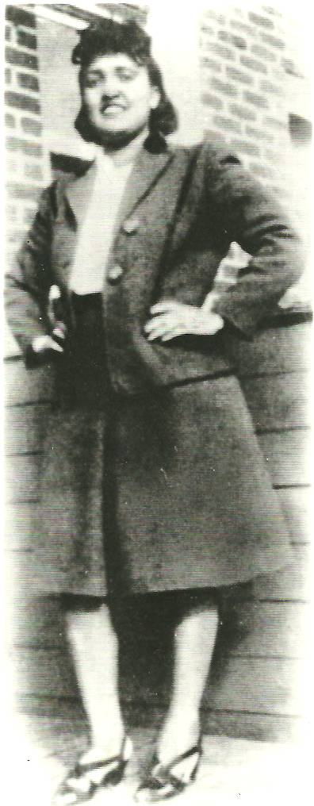
1. Review Guidelines of Belmont Report
https://www.youtube.com/watch?v=zZ3l1jgmYrY

2. Watch the movie and answer questions 1-14 as you watch the video.
https://www.youtube.com/watch?v=22lGbAVWhro

- What thing is small enough to float on a speck of dust can help us answer questions about cancer, virology, and genetics?
- Why do we study cells in the lab?
- What do scientists need to be able to study cells and recreate experiments in the lab?
- What was the name of the Johns Hopkins doctor that received the sample of the “strange looking tumor”?
- Why was this sample “special”?
- What did they name this special cell line?
- When was Henrietta born? When did she die? (look above)
- What allows the HeLa cells to stay alive when others die?
- What did Gey do with the cells when he realized they were immortal?
- How many cells did cell productions companies make a week? What are these companies getting due to this?
- When was the cell sample taken? When did her family find out?
- Who used HeLa cells to test the polio vaccine?
- What are 4 other diseases that HeLa cells have helped scientists study?
From the HeLa cell line scientists have discovered chromosomes, they were the first to be cloned, they have traveled to outer space, HPV and its vaccination was discovered, along with countless other things. So this is great! Let’s celebrate… Not so fast…
- How did Henrietta feel about doctors using her cells?
3. Family Information
Now watch this video https://www.youtube.com/watch?v=ldnRUtQeryg
Reflection:
- What is the family’s position? What are the 2 things they are “upset” about? Discuss this. Do you agree with them or not? Give 2 reasons to support your position. (3 – 4 sentences)
This is a complex issue. Henrietta Lacks’ cells have given so much to the world (From the HeLa cell line scientists have discovered chromosomes, they were the first to be cloned, they have traveled to outer space, HPV and its vaccination was discovered, along with countless other things) but there are a few issues here:
A. The family of the women whose cells have changed medicine, and continues to do so, can’t afford health insurance.
- Although Lacks signed a “consent form” she and her family were unaware her cells were being used in research and then eventually supply companies made billions of dollars from them.
- Henrietta was a poor, uneducated, black, tobacco farmer that went to Johns Hopkins Hospital for treatment because that was the only place she COULD go in 1950. Some believe that patients there, including Lacks, were taken advantage of because of their race.
- Pick one of these above stated issues and discuss how it makes you feel. Do you think things should be different? If so how? (2 – 3 sentences)

